How to clean intermittent buttons on Express
Buttons will occasionally register presses
Express face panel test
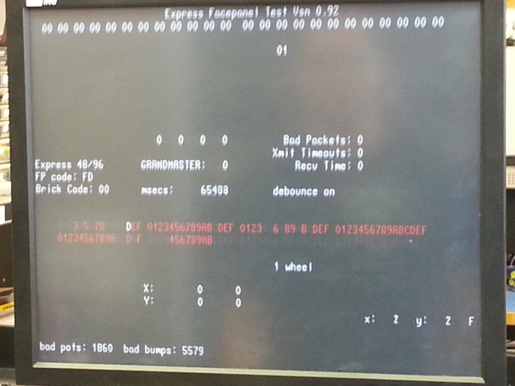
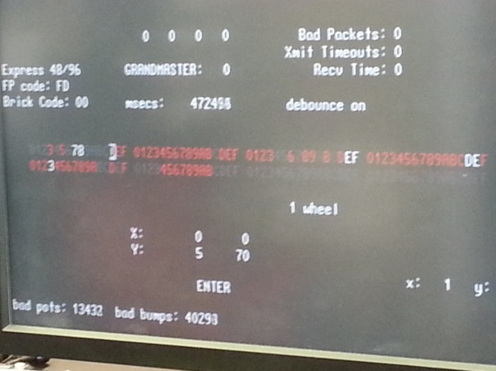

Button hit registered No button hit registered
(Button pressed)
Ideal Tools
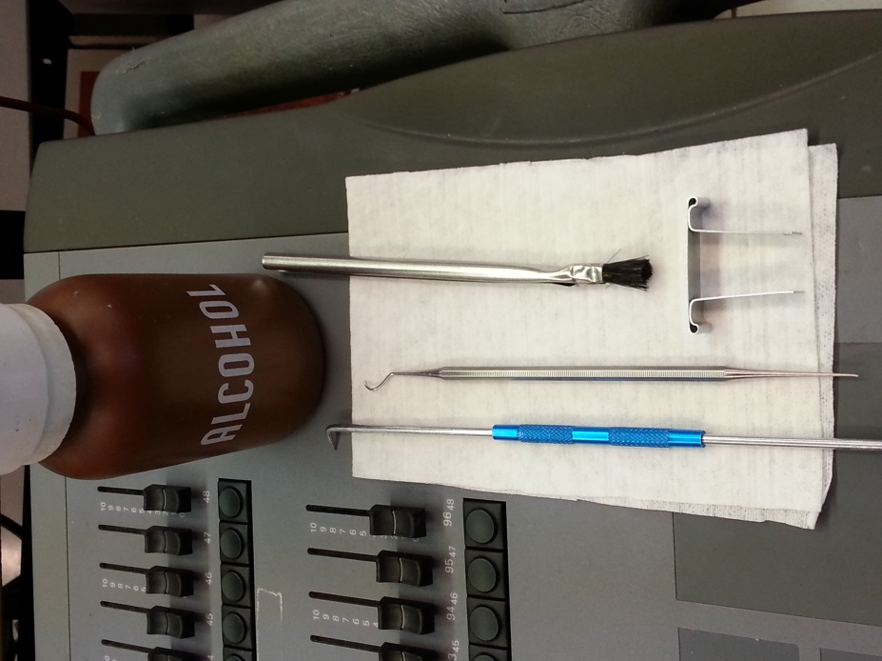
Key cap remover
Scribe x2
Isopropyl alcohol
Small brush
Step 1:
Remove affected button cap
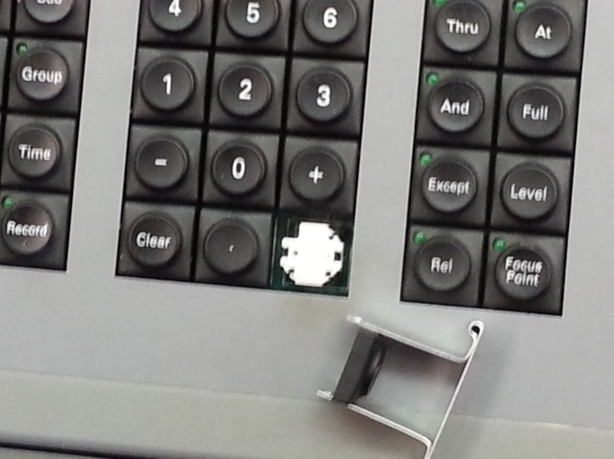

Step 2:
Place the end of a scribe under one of the sides of the button. Use the other scribe to rest on to avoid damage to your console’s face panel. Be sure to pull out as well as up to avoid cracking white key cap.
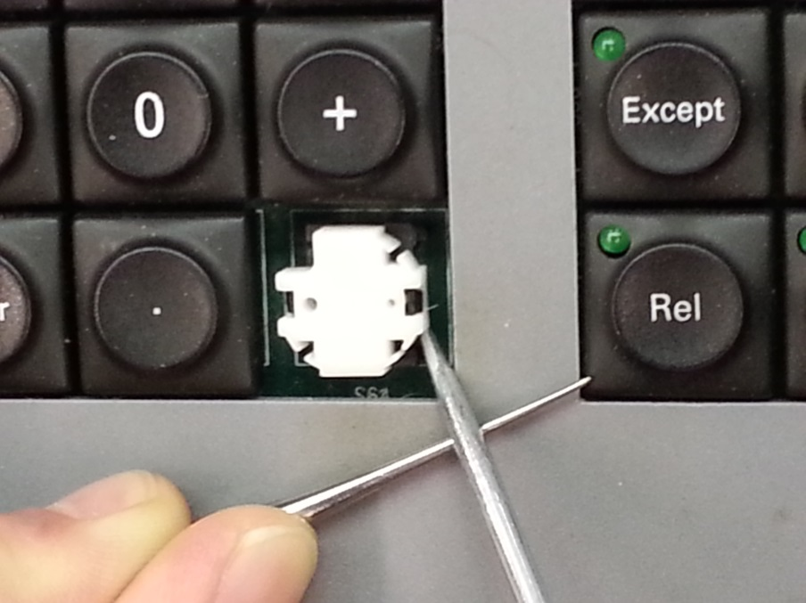
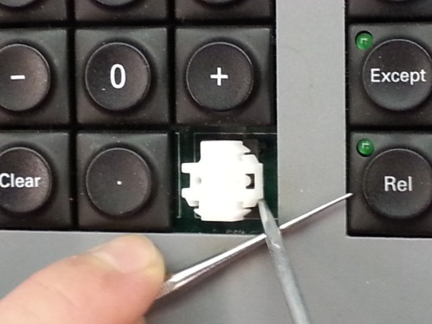

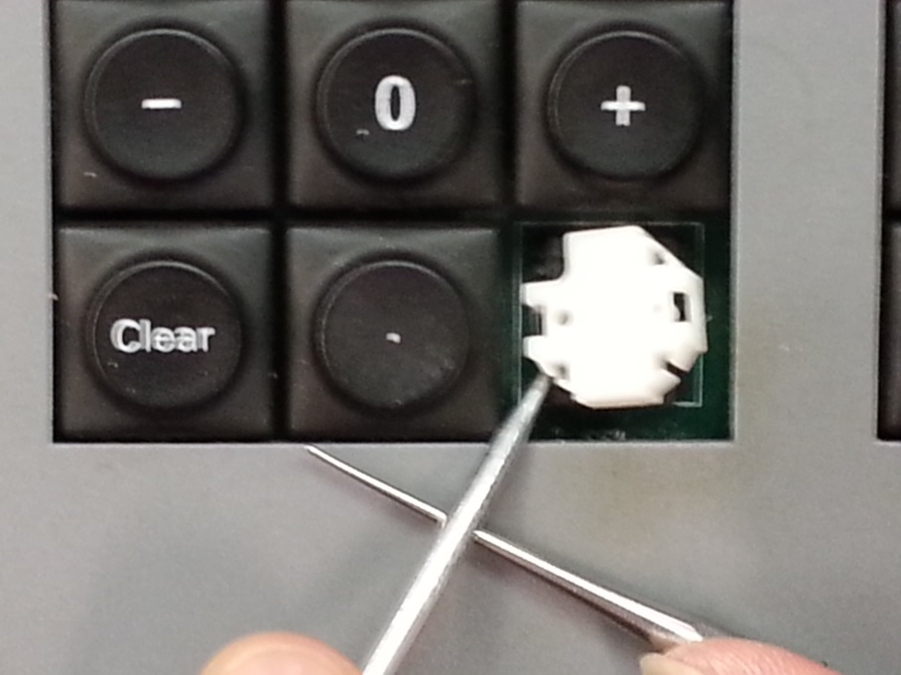
Repeat process for other side.

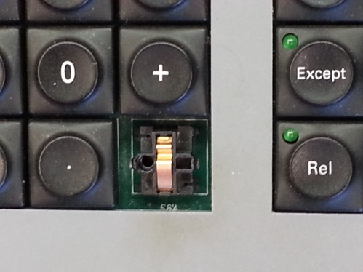

Step 3:
Use scribe to remove copper piece.
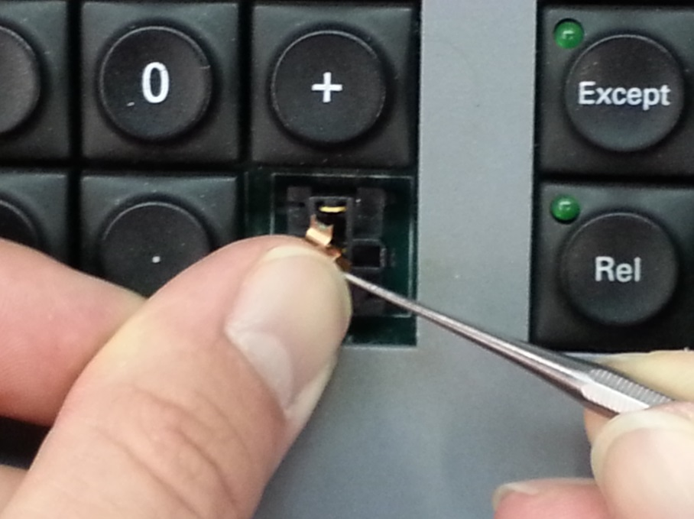
Caution: It is under tension and may shoot out like a spring.

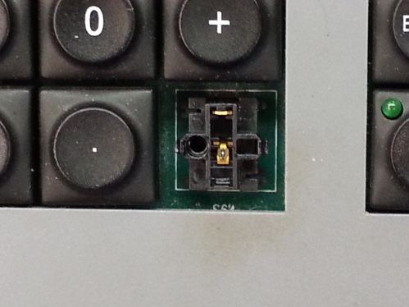

Step 4:
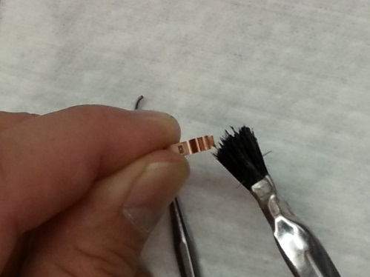
Scrape off residue with scribe and clean copper piece and button with alcohol.
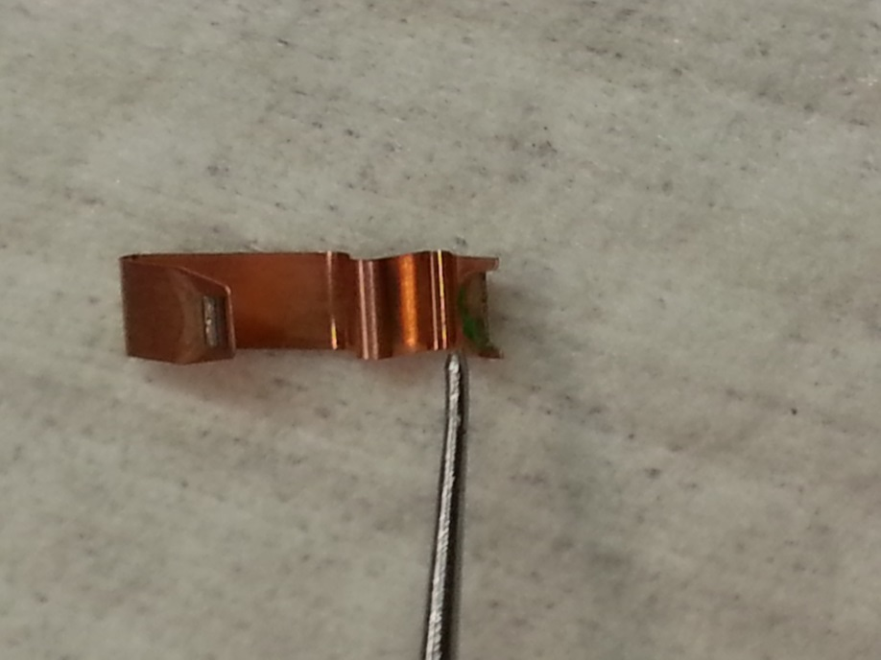
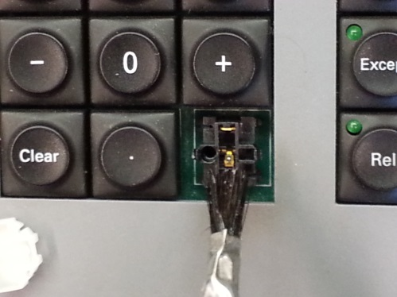

Step 5:
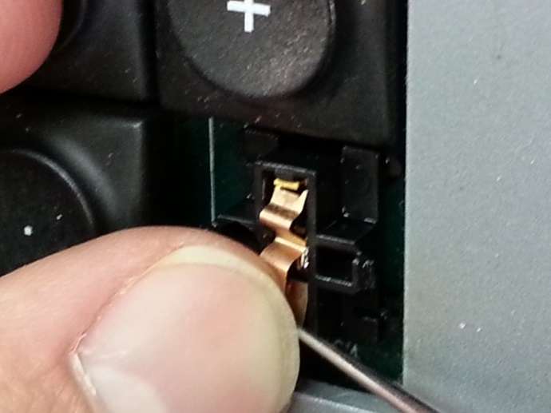
Replace copper piece, seating the top (fork) first, then set bottom.
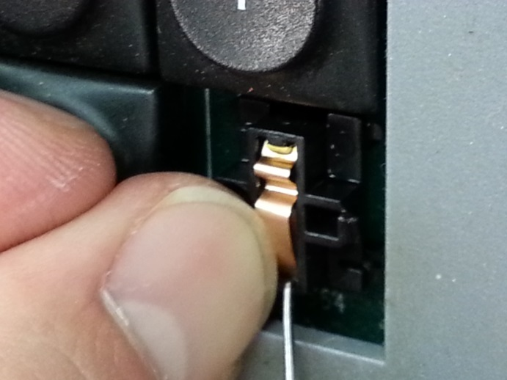

Step 6:
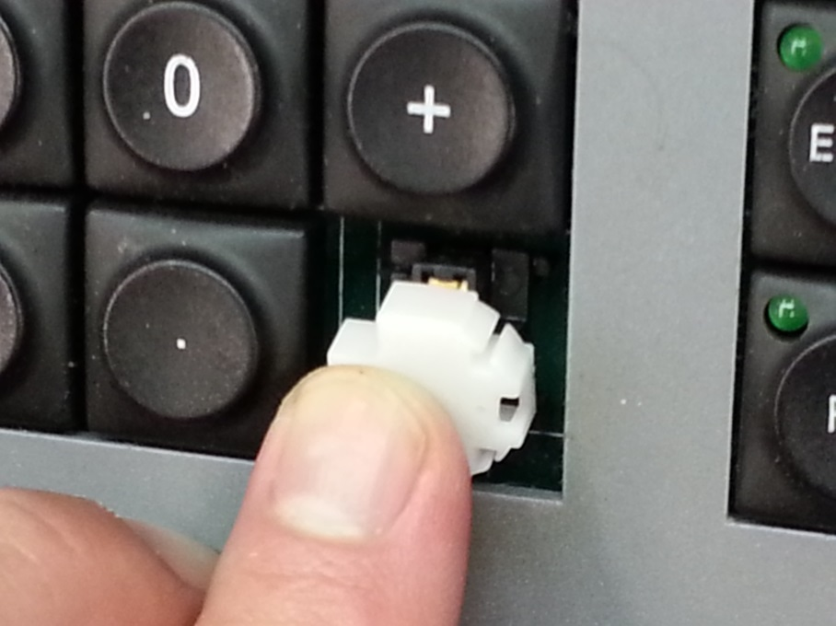
Replace white cap and label cap then confirm button’s functioning.
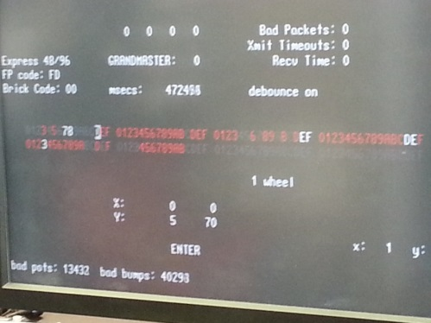

**Steps for buttons with LEDs are the same. If the button remains depressed once you’re done, the LED is not centered in the hole. Realign and your good to go!
